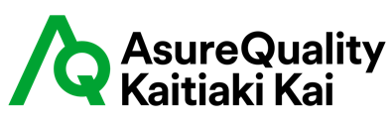

Organic Livestock Transport Driver Declaration

To all transport staff:

AsureQuality organic certified livestock are differentiated high value products and under the AsureQuality Organic Standard (5.12) there are requirements with regards to the handling of these livestock to ensure their Organic status is upheld during transport.

These Include:

- Transport and holding of livestock must be carried out so as to limit the stress suffered by the animals in accordance with the relevant NZ legislation in force.

- Management of certified organic livestock must ensure that:

  - Stress is reduced
  - Loading and unloading is carried out without the use of any type of electronic or chemical stimulation to coerce the animal
  - Mixing of certified organic stock with conventional or in- conversion stock does not occur during transport.
  - Certified Organic Livestock are not transported for more than 8 hours (or 5 hours if certified to Canada Organic Standard).
  - If unloaded for food and water this will need to occur at a certified organic premise.
  - Providing animals with non-organic feed (dried feed or access to pasture), is likely to affect their organic certification. Therefore, in the event of a breakdown the owner of the stock should be contacted.

It is essential that you are always aware of the need to protect the integrity of these products by ensuring that the certified livestock are not contaminated in any way or mixed with non-certified livestock. Any loss of integrity of these products would jeopardise the organic certification status of this product.
---------------------------------------------------------------------------------------------------------------------------
Name of Transport Operator Company:

I have read and understood the above requirements and the integrity of the livestock organic status as required above will be maintained.

Signature:

Date:

Please provide the driver a copy of the completed form to have on hand when transporting organic animals.

